** San Francisco Bay University**

**EE461L - Verilog HDL Lab**

**Week#1 Introduction to Verilog and**

**Combinational & Sequential Logic Design**

Name: Melvin Divine Pritchard Student ID: 19857

**Answers :**

**1.**

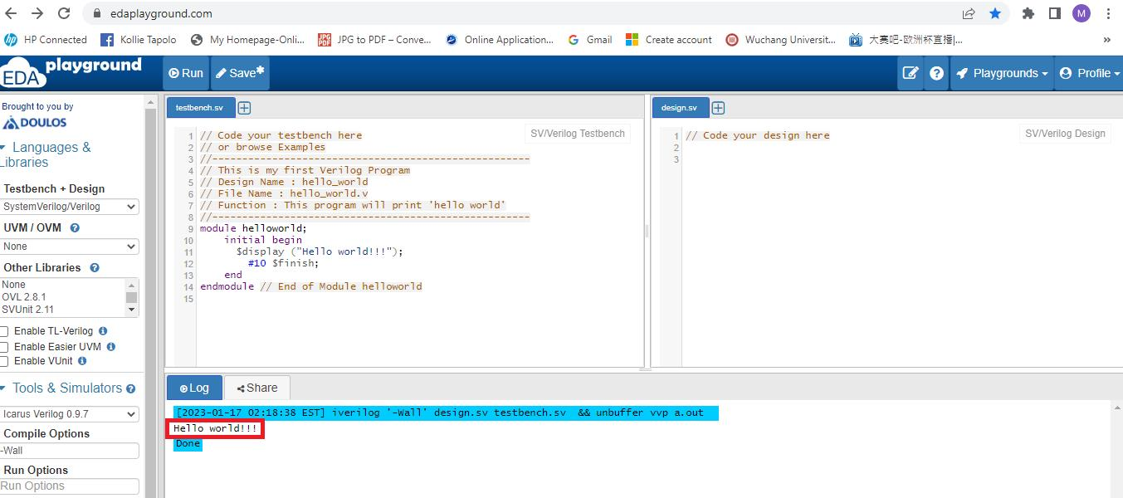

**2.**

